Chubritza

Design Document

by Anastas Kuyumdzhiev and Rozalina Miladinova

Contents

**Introduction** 3

**Target Audience** 3

Individuals 3

Why People Visit 4

Key Motivations 4

Specific Goals 4

Information Needed 4

Visitor Frequency 5

Conclusion 5

**Site Map** 5

**Wireframes** 6

Home 6

Log in 7

My account 8

My recipes 9

Saved 10

Register 11

Categories 12

Category Example 13

About us 14

**Design** 15

Visual Hierarchy 15

Size 15

Color 15

Style 16

Grouping and Similarity 16

Navigation 16

# **Introduction**

Every country has its own unique blend of cultural importance. For Bulgarians, our traditional kitchen is something that we cherish very much. That is exactly why we want to share it with others with the help of our website – Chubritza!

The name Chubritza originates from a spice that is thought of as the most Bulgarian spice. It is widely used in our cuisine. Our website wants to bring the wonders of the traditional Bulgarian kitchen to the Netherlands. We will offer numerous traditional recipes and more! Users can register and upload their own recipes. They can also leave feedback for the original uploader.

# **Target Audience**

## Individuals

**Age Range** – 14 and above  
Cooking is a hobby for everybody but children should not handle knives so our website will be focused on people from 14 and above, generally, we expect to have people around 30 to 50 years old.  
**Appeal** – More to women  
It is widely accepted that cooking is a women’s hobby. That may not always be the case but we expect to have more women than men browsing our website, looking for new recipes for their kids.  
**Country** – the Netherlands  
Our goal is to introduce Bulgarian food to the Netherlands, which is why we expect most of our visitors to live there.   
**Average income** – Around 30,000 per year  
We don’t expect the majority of our visitors to be very rich. You won’t need to make much money to use our site efficiently.  
**Level of education** – At least a high-school diploma  
The average user will have finished high-school for sure, but some people may not have gone to college.  
**Marital Status** – Mostly married  
We think that most of our visitors will be married women that need new recipes. There might also be people that are interested in Bulgarian culture, but visitors will be predominantly married.  
**Web usage** – At least 5 times a week  
People use the Internet more and more these days, so we believe that this number is very subjective. However, the average visitor will probably not be the most avid users of the Internet.  
**Device for access** – Personal computer  
Most people will want to look up a recipe on their computer and write it down if they like the look of it.

## Why People Visit

### Key Motivations

**What are visitors looking for?** – Specific goal  
Visitors of our site will most probably be there with one goal in mind – to find a recipe that they want to try out. There might also be some people that just want to browse and look at comments but, in general, users will visit the site with a goal.  
**What kind of goal?** -Might be both personal and professional  
A culinary site might be user for inspiration or research by a professional cook or just as an experiment at a family dinner. Because most people do not make money from their cooking, the main goal of the visitors will be of a personal kind most of the time.  
**Spent time** – Essential  
Cooking is an essential skill to have if you want to survive. Now, we admit that Bulgarian cooking n particular is not needed if you know how to cook in general, but we do still believe that the activity is essential.

### Specific Goals

**Familiarity with the service** – Familiar  
People know what they are looking for if they end up in a website about cooking. There are recipes with descriptions and pictures. They do not need to be introduced to the subject.  
**Contact** – No  
There should be no need to contact us directly in any way.

## Information Needed

**Familiarity with subject and brand** – Probably familiar with subject, not familiar with brand  
We expect most of our initial visitors to be Bulgarians living in the Netherlands, looking to remind themselves of their home country. In that case, they will be familiar with the subject already. We are a new brand so we will need to introduce ourselves.  
**Most important features** – Commenting and uploading  
The most important features of our website will be the ability to interact with other people by starting discussions and uploading your own recipes.  
**What differentiates us?** – A whole new world of cooking  
What makes our website unique is that we concentrate on Bulgarian cuisine. Visitors will learn about a culture they might not be familiar with and they will enjoy the good food on top of that.

## Visitor Frequency

**How often is the subject updated?** – If uploading new recipes doesn’t count – not very often  
The only thing that our website might need to update is its recipes. That is not done very often and will be done by the users that have uploaded the recipes

## Conclusion

Our vision of the average visitor of our website is a middle-aged woman that is married with kids. She uses the internet from time to time, mostly to look up recipes for her family. She uses our site with a specific goal in mind – to find new recipes related to the Bulgarian kitchen. She is looking for different recipes that involve different ingredients. She wants to have the option to search based on the ingredients that she wants to use. She would also like to be able to upload her own recipes.

# **Site Map**

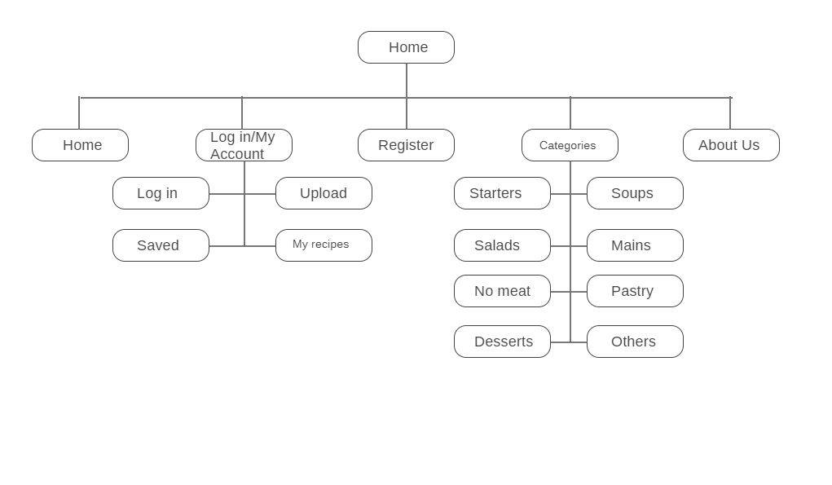

# **Wireframes**

## Home

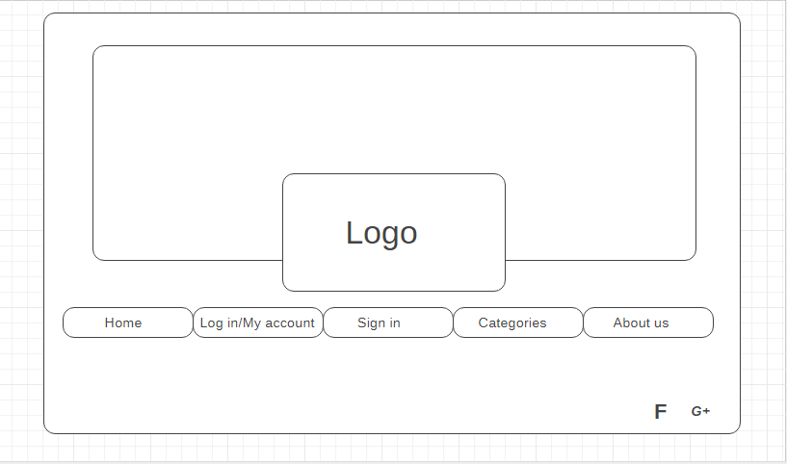

## Log in

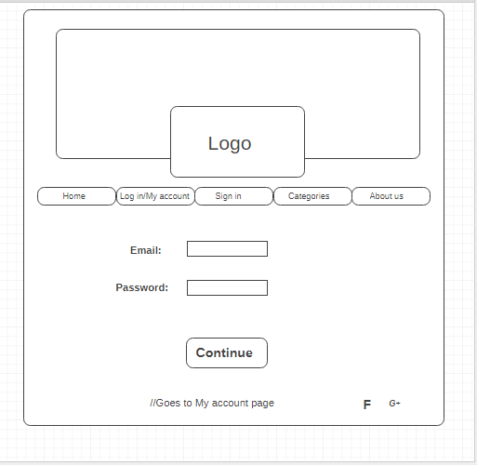

## My account

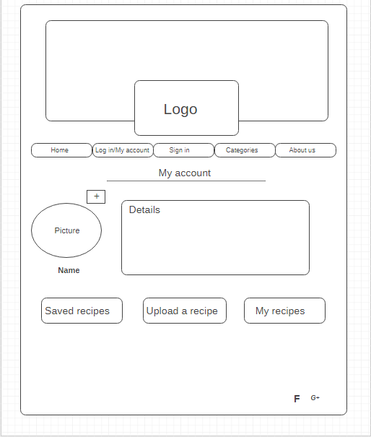

## My recipes

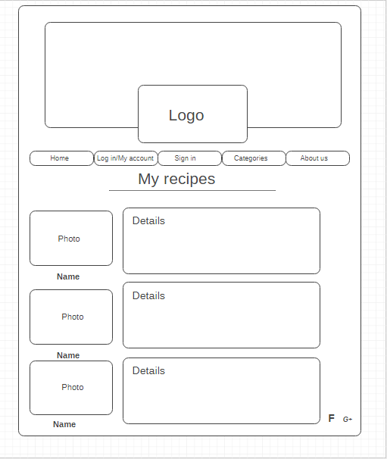

## Saved

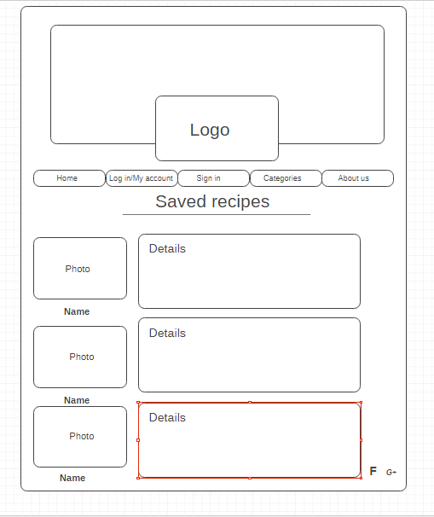

## Register

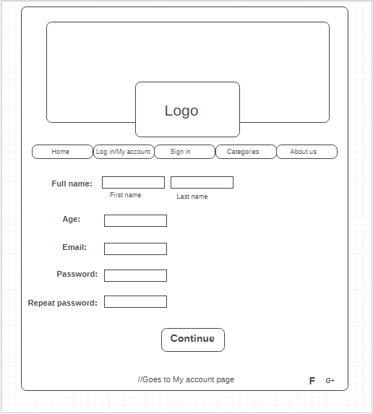

## Categories

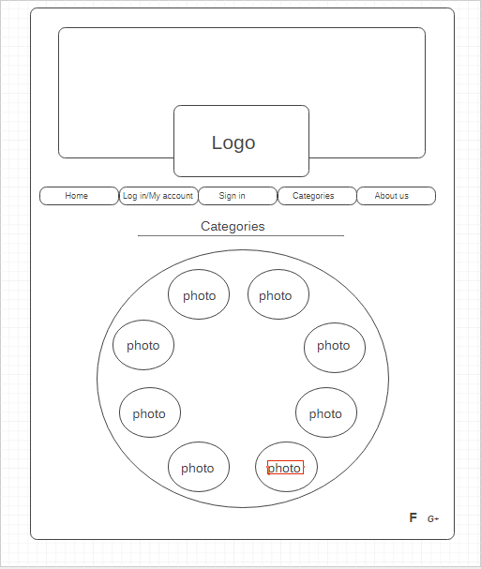

## Category Example

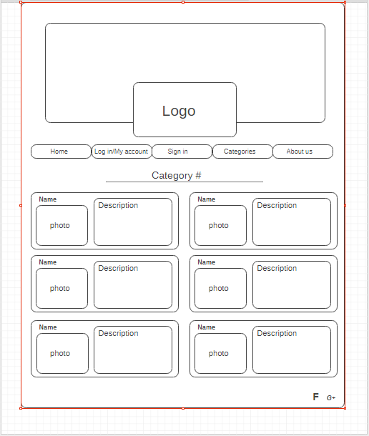

## About us

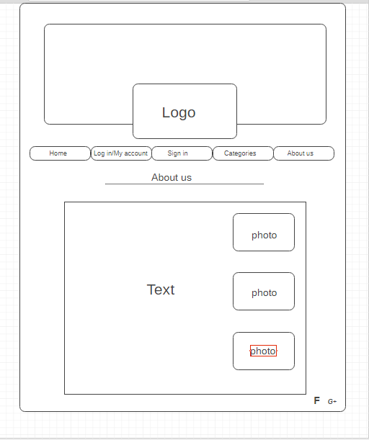

# **Design**

## Visual Hierarchy

### Size

The main point of our website are the recipes. Because of that, whenever there are recipes on screen, they will be the largest element. In that way, people will be able to skim through recipe photos and find what they like.  
In other cases, the logo of our website will be the largest element.  
The size of the text when it comes to the recipes themselves will focus on the titles. A short description of the food will be present, which has a smaller font.

### Color

As mentioned before, Chubritza is a website about traditional Bulgarian food. As such, the design of the site will be closely related to traditional Bulgarian colors and patterns.

Here are some samples:





### Style

The titles of the different recipes need to stand out the most. They will be stylized in a way that makes them catch the eye. The descriptions will be plain and simple, to further emphasize the surrounding elements.  
The background of the site will be more transparent to give way to the foreground.  
User comments will be placed at the bottom of the page, so they do not interfere with the main content.

## Grouping and Similarity

Different recipes will be grouped together with the help of proximity when a specific category is selected. Otherwise, we will use white space to separate them. We will also use borders to show the individuality of a recipe.   
In terms of similarity, all the recipes will be consistent when it comes to their layout and design. They will have photo on the left, the title on the right, with the ingredients directly below it. The description of the recipe will be the main part of the page and placed in the middle.

## Navigation

The navigation menu will be concise and easy to read. There will be just five elements so they don’t clog the page. When a page is selected, the style of the selected element will change to indicate the change of the page.  
The categories page will have a wheel bar that is used to select the desired category of food. All of its elements will be highlighted when the cursor is placed on top of it.